From: https://libertyblitzkrieg.com/2019/08/26/insiders-dont-criticize-other-insiders/

Insiders Don’t Criticize Other Insiders
Michael Krieger | Posted Monday Aug 26, 2019 at 2:47 pm
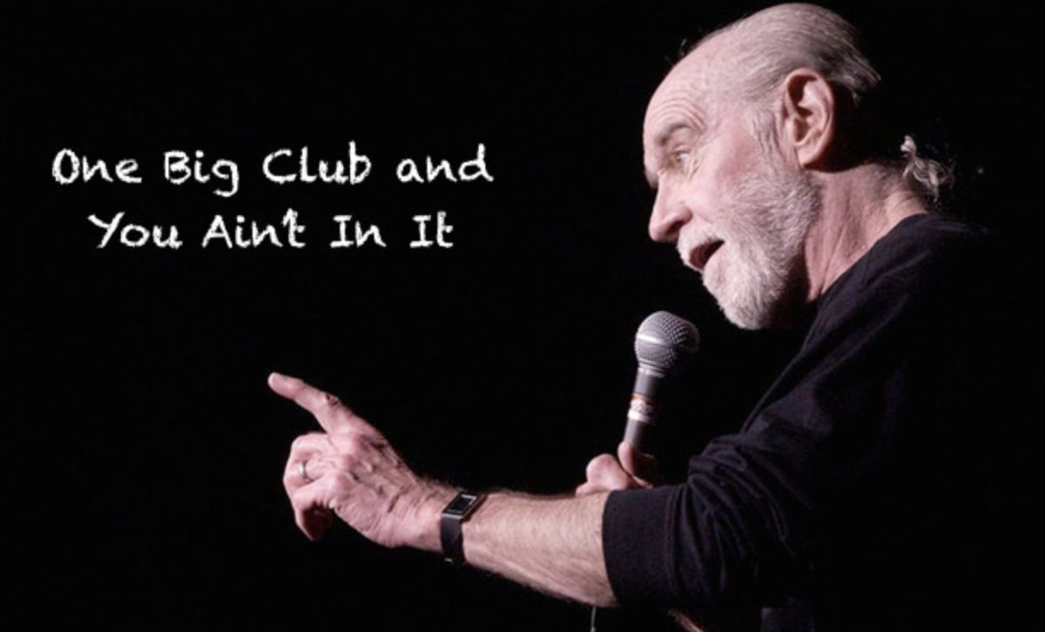
Since leaving office President Obama has drawn widespread criticism for accepting a $400,000 speaking fee from the Wall Street investment firm Cantor Fitzgerald, including [criticism] from Senators Bernie Sanders and Elizabeth Warren. Only a few months out of office, the move has been viewed as emblematic of the cozy relationship between the financial sector and political elites.
But as the President’s critics have voiced outrage over the decision many have been reluctant to criticize the record-setting $65 million book deal that Barack and Michelle Obama landed jointly this February with Penguin Random House (PRH)…
While the Obamas’ deal is unique for the amount of money involved, outsized book contracts between politicians and industries they’ve benefitted has precedent. In a recent report issued by the Roosevelt Institute, the study’s authors, Thomas Ferguson, Paul Jorgensen, and Jie Chen, argue that the mainstream approach to money in politics fails to recognize major sources of political spending. Among the least appreciated avenues for political money, they argue, are payments to political figures in the form of director’s fees, speaking fees, and book contracts.
From the 2017 Naked Capitalism piece: The “Market Forces” Behind the Obamas’ Record-Setting Book Deal
Back in 2009, when the Obama administration was busy ensuring the nation’s financiers would become larger, more powerful and never serve a day in jail despite their historic crime spree, Larry Summers had dinner with Elizabeth Warren. During the course of that meal, he instructed her about how power really functions in the U.S.:
[In the above reference and below, a closing quote is assumed to exist, if needed, just before any paragraph mark.]
A telling anecdote involves a dinner that Ms. Warren had with Lawrence H. Summers, then the director of the National Economic Council and a top economic adviser to President Obama. The dinner took place in the spring of 2009, after the oversight panel had produced its third report, concluding that American taxpayers were at far greater risk to losses in TARP than the Treasury had let on.
After dinner, “Larry leaned back in his chair and offered me some advice,” Ms. Warren writes. “I had a choice. I could be an insider or I could be an outsider. Outsiders can say whatever they want. But people on the inside don’t listen to them. Insiders, however, get lots of access and a chance to push their ideas. People — powerful people — listen to what they have to say. But insiders also understand one unbreakable rule: They don’t criticize other insiders.
“I had been warned,” Ms. Warren concluded.
I’ve been thinking about this a lot lately, particularly in the context of the Jeffrey Epstein saga. Whether or not he was linked to one or more intelligence agencies, Epstein was undeniably the consummate insider. [Not exactly. See, e.g., the Jennifer Matsui 'La Danse Mossad article or the yyyyyyy] He was involved in close relationships with a vast cross-section of “elite” American society that crossed all political lines, yet nobody ever called him out for what his real job apparently was — the sexual abuse and trafficking of children. Now that he’s dead though, all these respectable denizens of high society; from former presidents, to billionaires and British royals, are in complete shock. Nobody knew!
While some of his more casual acquaintances may have been entirely ignorant, nobody has convinced me that those closest to Epstein over the years didn’t have at least some understanding of what was going on. The U.S. government knew what he was up to when he was given his ridiculous and unprecedented sweetheart deal in 2008. They knew, but it didn’t matter. Insiders protect other insiders.
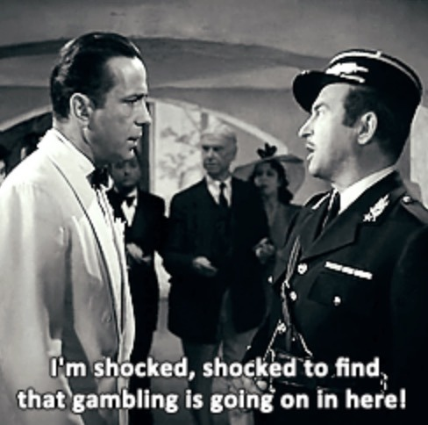
Many of the elites surrounding Epstein may not have known the entire picture, but they must have known something was off. Nevertheless, they continued to party with the guy and protect him. For some, silence on Epstein may have been driven by fear, while others may have wanted to continue to participate in his “services,” but perhaps something else was also going on. Epstein was an insider, and insiders don’t criticize other insiders. Larry Summers, another consummate insider, said so himself.
A cozy meal with Jeffrey Epstein, Alan Dershowitz and Larry Summers.
This is your so-called American "elite".
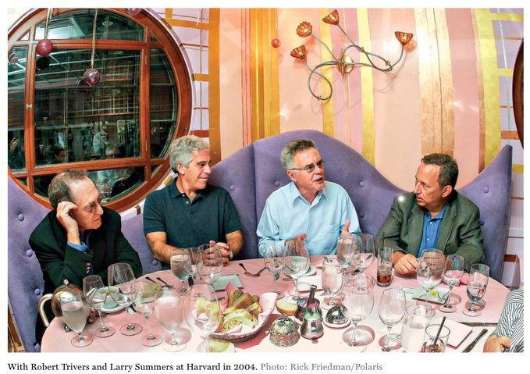
If this is in fact the code Larry Summers and other insiders live by, then it’s not a stretch to think these people would simply never criticize one of their own. This twisted mentality is a big part of why super predators like Epstein can spend their entire lives abusing children and never face justice. I guess this is how sociopaths operate.
It’s also worth noting that Larry Summers gave that insider speech to Elizabeth Warren years before she was elected to the U.S. Senate. He was warning her that unless she stopped causing problems and agreed to play the game by this gangster code, she would never get anywhere and no one would ever listen to her.
Additionally, Summers can’t pretend his commentary to Warren was some off the cuff statement he later regretted. He said almost the exact same thing to former Greek Finance Minister Yanis Varoufakis in the midst of that country’s crisis.
Via The Guardian:
Yet Varoufakis’s account of the crisis that has scarred Greece between 2010 and today also stands in a category of its own: it is the inside story of high politics told by an outsider. Varoufakis began on the outside – both of elite politics and the Greek far left – swerved to the inside, and then abruptly abandoned it, after he was sacked by his former ally, Greek prime minister Alexis Tsipras, in July 2015. He dramatises his intent throughout the crisis with a telling anecdote.He’s in Washington for a meeting with Larry Summers, the former US treasury secretary and Obama confidant. Summers asks him point blank: do you want to be on the inside or the outside? “Outsiders prioritise their freedom to speak their version of the truth. The price is that they are ignored by the insiders, who make the important decisions,” Summers warns.

Like this post?
Donate bitcoins:3J7D9dqSMo9HnxVeyHou7HJQGihamjYQMN
Follow me on Twitter.


Share this:
- Click to share on Twitter (Opens in new window)
- Click to share on Reddit (Opens in new window)
- Click to print (Opens in new window)

Categories: Uncategorized Tags: elites Jeffrey Epstein, government by sociopaths, Larry Summers insiders, Larry Summers insiders comment, Obama book deal, Obama oligarch Comments: 5
← Believing Jeffrey Epstein Committed Suicide is the Real Conspiracy Theory

5 Comments

